MATH NEWS
Second Grade Newsletter Summer/Fall
Math Tips for Families Unit 3: Addition and Subtraction within 100

Unit 3: Addition and Subtraction within 100 and comparing #s.  This unit follows the “Extending Place Value” unit where students continued to develop their number sense. Within this unit, students will learn and apply various strategies based on number sense, mental mathematics, and the relationship between addition and subtraction within 100. As they solve addition and subtraction word problems, they will use concrete manipulatives to conceptualize the concepts as they use strategic thinking and a variety of tools such as; open number lines, hundred charts, expanded form (one hundred+ 5 tens+ 3 ones) and decomposing (breaking apart), and explaining their thinking  In this unit, students will also use a variety of materials and solve word problems using objects pictures, words and numbers, and money. Part of their ongoing practice with addition and subtraction will include adding amounts of 10, 5, and 1. This will lead to understandings of patterns and tie in with the real world values of coins and money. They will also be comparing different values. |  |  |  | What came before Foundation Skills  In first grade, students worked on addition through 20, as well as subtraction. They also had many opportunities to add multiples of ten ( 20, 30, 40, 50, etc.) to two digit numbers. For example, 47 + 20. Subtraction was taught as well, using a variety of math models to conceptualize the values.  Now, we move on from small sums to two digit addend with larger sums like: 47 + 18. Students will represent numbers paying special attention to tens and ones.
Comparing 3 Digit Numbers using place value  We read numbers from  left to right, just like words.  *make a visual representation first  _______ ______  This number this number  compared to  < Less than  >GGreater than  = Equal to  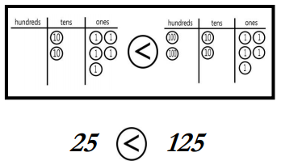 |  | Using Questions  What do you notice about this two digit number?  How can we tell if a two digit number is bigger than another two digit number?  In this situation, are we looking for a whole or a part?  How does “think addition” work for a subtraction problem?  How can you represent the tens and ones in this equation? |  | How You Can Help  Write a two digit number, ask your student to read the number, then draw different visual representations of the number. Be sure they chunk the values into tens and ones.  56 … Fifty-six or  5 tens and 6 ones.  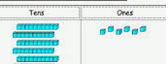  You can use:  Base ten blocks  Base ten symbols  Dimes and pennies
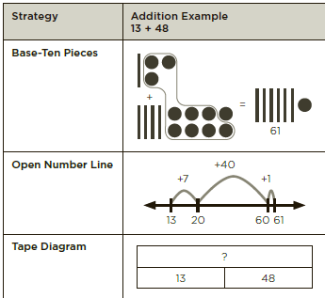 |  |  | Expanded Method for 2-digit Addition  Also known as partial sums. This method helps students to see that the placement of the digit matters. If the digit is in the first space on the right, it represents units of one, whereas if it is in the second place from the right it represents units that are tens.  ____ ____ 48 + 13  Tens Ones  48  48 = 40 + 8 + 13  +13 = 10 + 3__ 50 (4 tens + 1 ten)  61 50 + 11 = 61 + 11 (8 ones + 3 ones)  61
Key California Content Standards for this Unit

2.OA.A.1 Use addition and subtraction within 100 to solve one- and two-step word problems involving situations of adding to, taking from, putting together, taking apart, and comparing, with unknowns in all positions, e.g., by using drawings and equations with a symbol for the unknown number to represent the problem.¹

2.NBT.B.5 Fluently add and subtract within 100 using strategies based on place value, properties of operations, and/or the relationship between addition and subtraction.

2.NBT.B.9 Explain why addition and subtraction strategies work, using place value and the properties of operations.

2.NBT.7.1 CA Use estimation strategies to make reasonable estimates in problem solving.
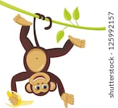  Sample Problem  Timmy the monkey picked 46 bananas from a tree. When he was done, there were 50 bananas left on the tree.  How many bananas were on the tree at first?  Think:  part  whole  part  Are we looking for a whole or a part?  ?  46 picked 50 left  Picked bananas (part)  10 10 10 10 1 1 1 1 1 1  Tree bananas (part)  10 10 10 10 10  All together (whole)  10 10 10 10 10 1 1 1 1 1 1  10 10 10 10 96 bananas in all! | Using an Open Number Line. 53 - ? = 17  Unlike a traditional number line, an open number line does not have equal spacing between the tic marks; it is not to scale. Students can use these to jump in different increments…ones, threes, tens, hundreds, etc., while solving sums (+) and differences (-). They use whatever values make sense to them. An emphasis is placed on using friendly numbers (ending in zero) and using chunks of ten to reinforce our number system. Students may think addition and add on or start at the greater number and hop backwards. 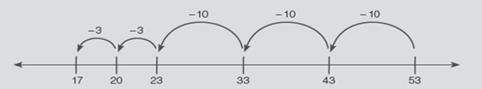
Sources Used in this Newsletter:
- California Mathematics Content Standards
- California Mathematics Framework
- Eureka Math Tips for Parents
- Lafayette Parish School System: “All Hands on Deck with Math” Topic Newsletters https://www.lpssonline.com/site5579.php

TUSD ~
Supporting community & family understanding

