MATH NEWS
Second Grade Newsletter Winter/Spring
Math Tips for Families Unit 6: Geometry

Unit 6: Geometry  In this unit, there are two major aspects to this unit:  - the attributes that define plane (flat) figures  - partitioning shapes into equal shares  Students investigate, describe, and reason about decomposing and combining shapes to make other shapes. Through building, drawing, and analyzing two- and three-dimensional shapes (in second grade- just cubes), students develop a foundation for understanding area, volume, congruence, similarity, and symmetry in later grades. |  |  | Before now…  Students build upon experiences in Kinder and first grade.  In Kinder they were exposed to number of sides, vertices/ “corners” and length of sides. They identified and described squares, circles, triangles, rectangles, hexagons, cubes, cones, cylinders, and spheres. They also made composite shapes out of smaller shapes and distinguished between 2 dimensional and 3 dimensional shapes. In first grade, they composed and decomposed two and 3 dimensional shapes and built an understanding of part-whole relationships as well as the properties of the original and composite shapes. They began working on seeing shapes and identifying them from different perspectives. They learned about closed figures, orientation, and size.
Words to Know  Parallel—two lines on the same plane (flat) figure are parallel if they do not meet.  Parallelogram—quadrilateral with both pairs of opposite sides parallel  Polygon—closed figure with three or more straight sides, e.g., triangle, quadrilateral, pentagon, hexagon  Quadrilateral—four-sided polygon, e.g., square, rhombus, rectangle, parallelogram, trapezoid  Thirds or a Third of (shapes),—three equal shares  A Whole can be made up of 2 halves, 3 thirds, or 4 fourths | Using Questions  - What shape is this and how do you know?  - How is this shape like this other shape?  - How are the shapes different?  - How can I partition this shape into 2, 3, or 4 pieces?  - How can I tell if the pieces that I partitioned are fair shares? |  |  | How You Can Help  Play with pattern blocks to notice the attributes of each shape :  - number of sides  - angles  - side lengths  - Which two shapes can make what other shape (a composite shape)?  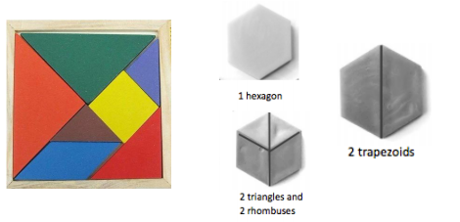  When drawing simple shapes, have your student practice dividing them into halves, thirds, and fourths (emphasizing equal-sized pieces).
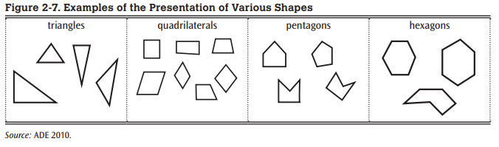
Key California Content Standards for this Unit

2.G.A.1 Recognize and draw shapes having specified attributes, such as a given number of angles or a given number of equal faces.¹ Identify triangles, quadrilaterals, pentagons, hexagons, and cubes.

2.G.A.3 Partition circles and rectangles into two, three, or four equal shares, describe the shares using the words halves, thirds, half of, a third of, etc., and describe the whole as two halves, three thirds, four fourths. Recognize that equal shares of identical wholes need not have the same shape.
Partitioning Shapes
Students partition circles and rectangles into two, three, or four equal shares (regions). Students explore this concept with paper strips and pictorial representations and work with the vocabulary terms halves, thirds, and fourths (2.G.3). Students recognize that when they cut a circle into three equal pieces, each piece will equal one-third of its original whole and the whole may be described as three-thirds. If a circle is cut into four equal pieces, each piece will equal one-fourth of its original whole, and the whole is described as four-fourths.
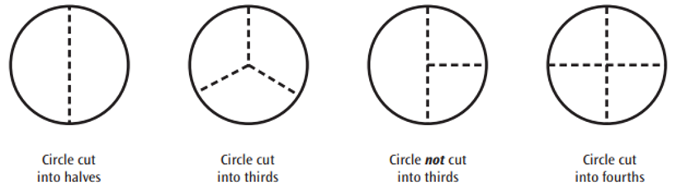
Students should see circles and rectangles partitioned in multiple ways so they learn to recognize that equal shares can be different shapes within the same whole.
TUSD ~  Supporting community & family understanding |  | Sources Used in this Newsletter:  - California Mathematics Content Standards  - California Mathematics Framework  - Eureka Math Tips for Parents  - Lafayette Parish School System: “All Hands on Deck with Math” Topic Newsletters https://www.lpssonline.com/site5579.php

