MATH NEWS
Second Grade Newsletter Winter/Spring
Math Tips for Families Unit 4: Measurement

Unit 4: Measurement. This unit is focused on the concept of measurement, both in time and linear measures. These skills, especially telling time, must be learned over an extended period. For grades pre-k through 2, the primary emphasis is on helping children develop a conceptual understanding of the measurement process and the units and tools of measuring length and time. The common measurement for measuring time is the clock, however, learning to tell time has little to do with measurement and more to do with the skills of learning to read an instrument. This is why we have coupled this skill with graphing. Rulers and graphs are also instruments of a kind. They have reference points or benchmark- tic marks. It is understanding the value of those marks and the spaces they separate that allows us to read any instrument. |  |  |  | Before now…  In First grade, students focused on telling time to the hour and half hour.  We will transition to telling time to the nearest five minutes.  Hour  Short hand  Minute  Long hand
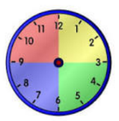  Key Terms  Clock face  Hour = 60 minutes  Half hour = 30 minutes  Quarter hour = 15 minutes  Line Plot  Number Line |  | Using Questions  - What do you notice?  - What hour are we in?  - Which hand shows us the hour? Minute?  - Can you count by 5’s?  - How many minutes past the hour is it?  - How many minutes until _______?  - How can a number line help us with time?  - How long do you think ___________ is? (using household items)  - How many Lego-pieces long is this bracelet?  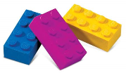  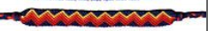 |  | How You Can Help  - Keep track of your child's growth each month by measuring his/her height using standard and non-standard units of measurement.  - Talk about graphs in newspapers and magazines.  - Take a family survey and make a graph based on the data.  - Create a bar graph based on the amount of time your child reads, plays outside, or watches television  - Display an analog clock near a digital clock (like the one on the stove or microwave) and have kids notice how they represent the time.  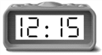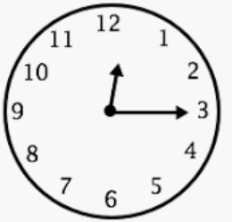
Measurements on a broken number line  We want to be sure that we notice how we are measuring-  - What are the benchmark numbers ?  - Did the ruler line up with zero ?  - If not, what is the difference between the end points?  - How many units long is the pencil?  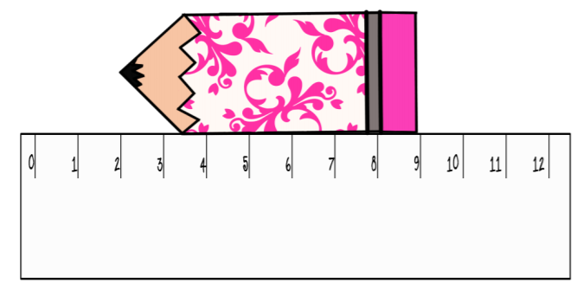 |  |  | Commonly used units of measurement:  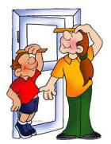  inches  centimeters  non-standard units:  paperclips  shoes,  coins,  etc.  Think: What is the difference in their heights?
Key California Content Standards for this Unit

2.MD.C.7 Tell and write time from analog and digital clocks to the nearest five minutes, using a.m. and p.m. Know relationships of time (e.g. minutes in an hour, days in a month, weeks in a year). CA

2.MD.D.9 Generate measurement data by measuring lengths of several objects to the nearest whole unit, or by making repeated measurements of the same object. Show the measurements by making a line plot, where the horizontal scale is marked off in whole-number units.

2.MD.D.10 Draw a picture graph and a bar graph (with single unit scale) to represent a data set with up to four categories. Solve simple put-together, take- apart, and compare problems using information present in a bar graph.
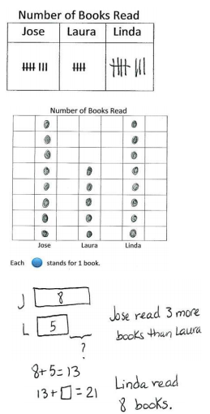 | 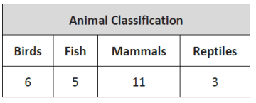  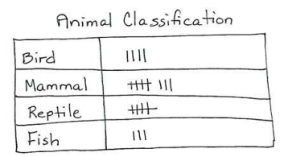  Students sort and record data into a table using up to four categories; use category counts to solve word problems.
Use a number line to practice counting minutes in chunks of five.

A clock is a circular number line!
Use a number line to practice counting hours- start over at 12 noon
8am 9 10 11 12 1pm 2 3 4 5 6 7 8

Sources Used in this Newsletter:
- California Mathematics Content Standards
- California Mathematics Framework
- Eureka Math Tips for Parents
- Lafayette Parish School System: “All Hands on Deck with Math” Topic Newsletters https://www.lpssonline.com/site5579.php

