1. <https://www.tracy.k12.ca.us/students>
2. Click on the icon called Destiny

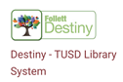

1. Hit Red box ‘Continue’

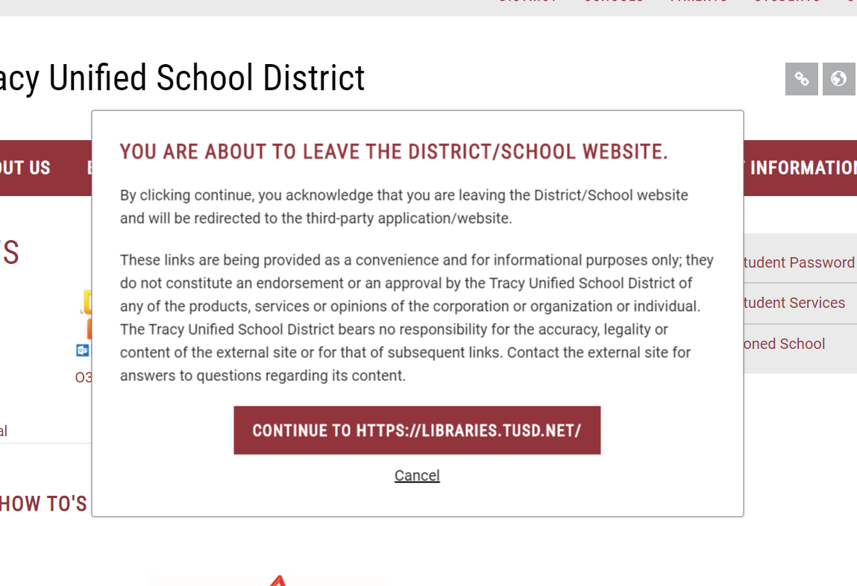

1. Choose Bohn Elementary School

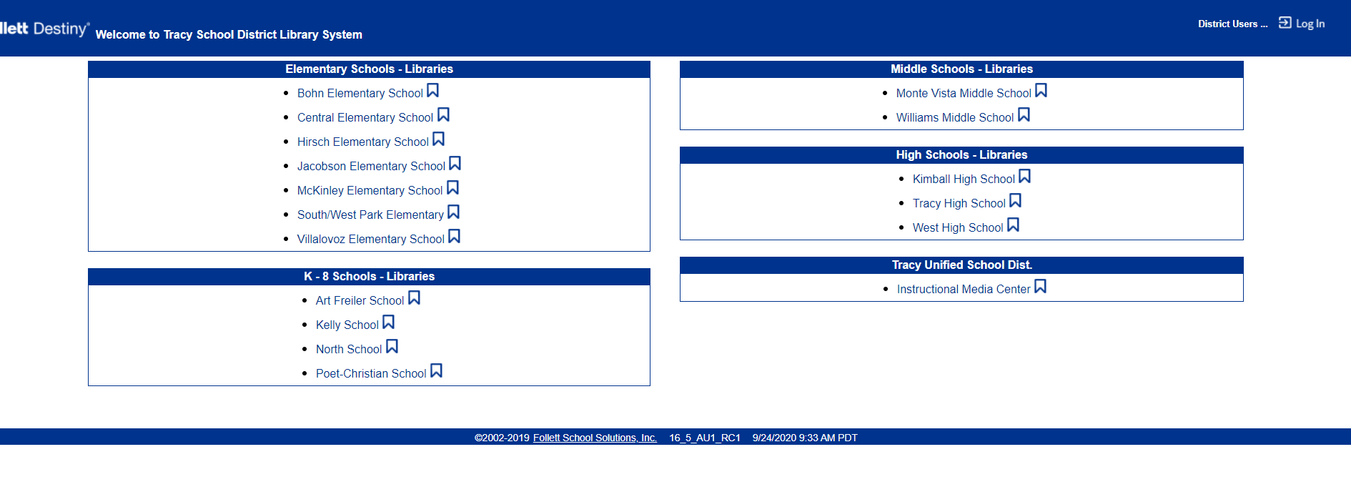

1. Click on Log In (right hand side of screen)

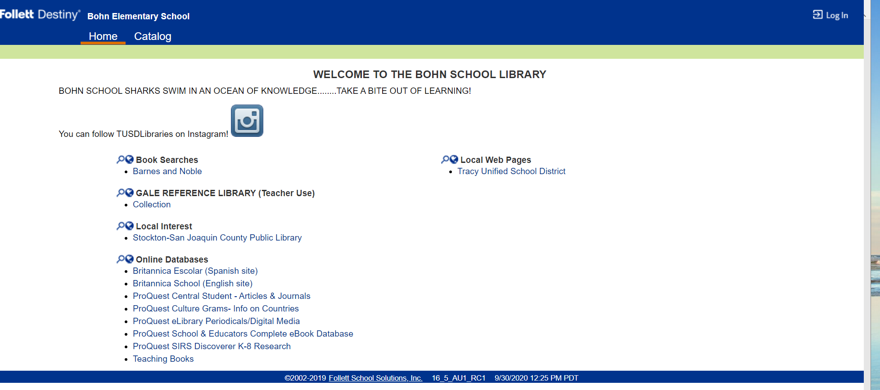

1. Click on Tracy-SSO (left side of screen) 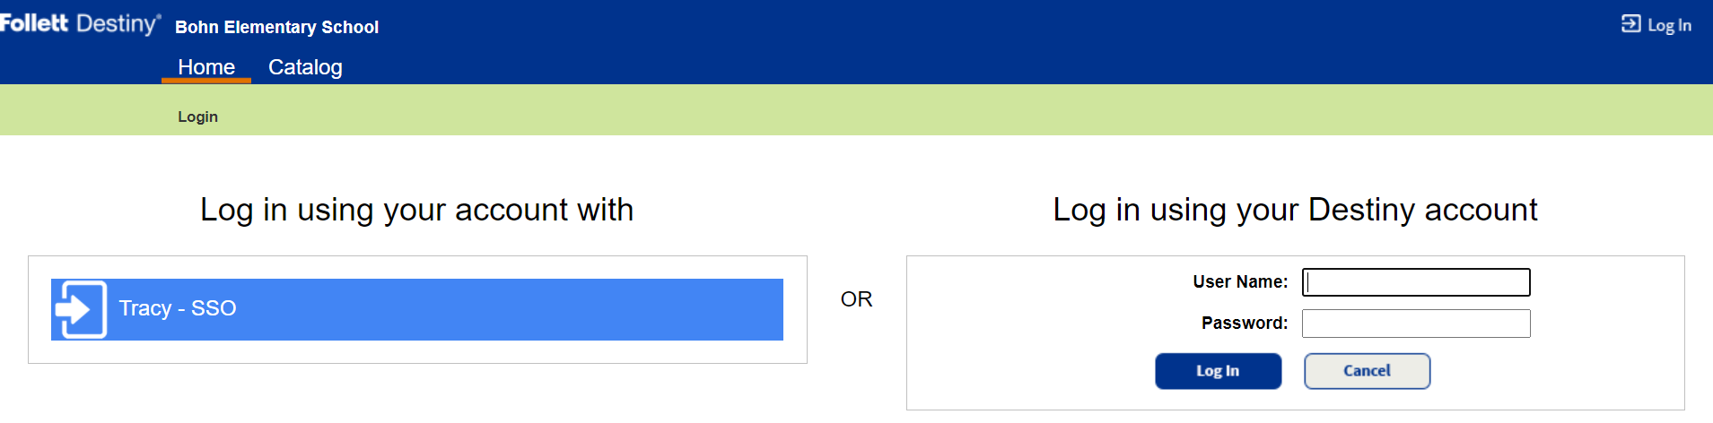
2. Over to right hand of screen, type your student log in.

username: student id number@student.tusd.net

 password: birthdate in this format 0922020

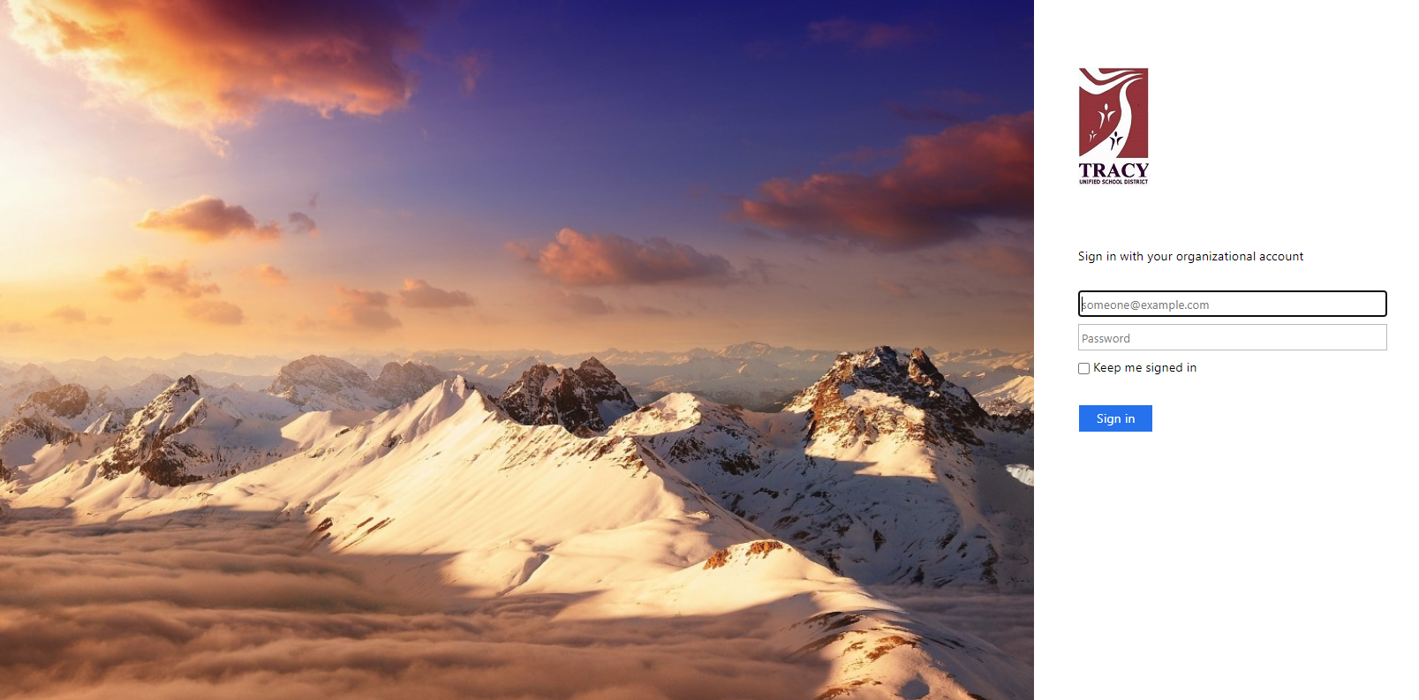

1. Click on Destiny Discover (left hand side)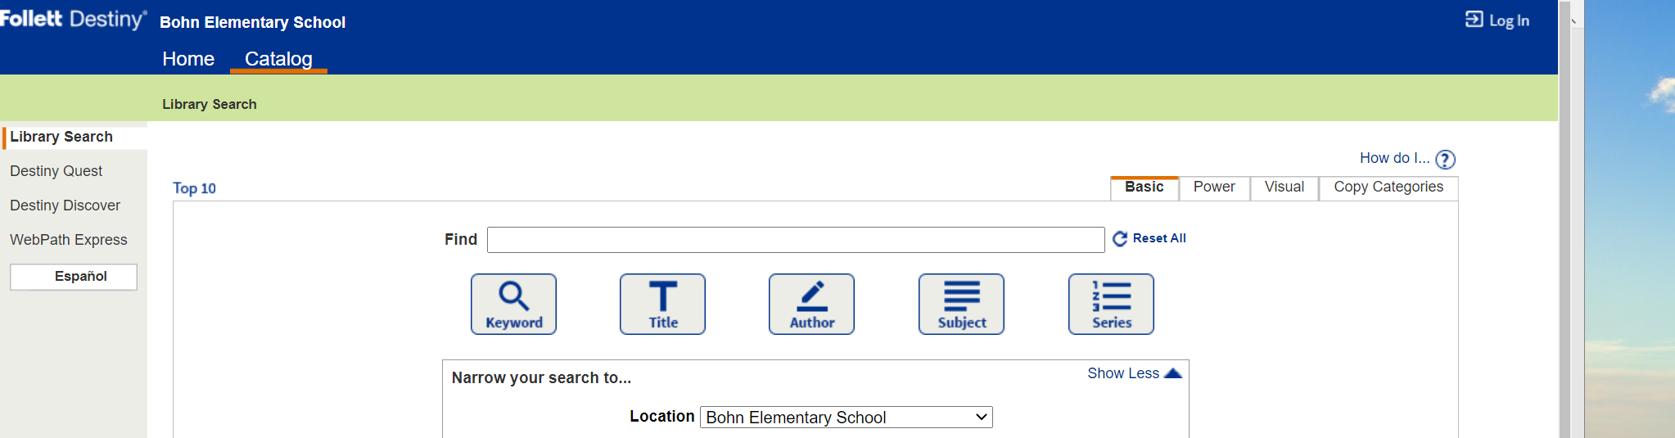

9. Search for the books you are interested in

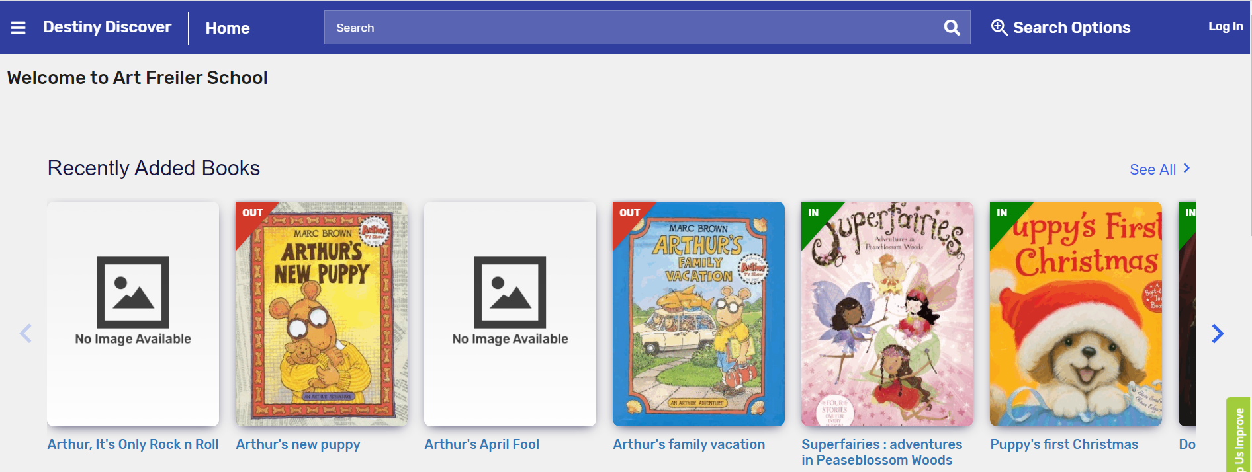

 Once you find a book you would like, click "hold” - You are allowed to hold 2 books

1. Log Out